How CAN I tell if I have a hearing loss?
Because hearing loss usually occurs gradually, most people don’t notice the subtle changes in their hearing. You may have damaged your hearing if you have experienced any of the following:
- Ringing in the ears after being exposed to loud sounds or listening with earphones
- Others have told you that the volume is too high on your car stereo, walkman, TV, etc.
- You often ask others to repeat things or to speak more clearly
- Others have suggested that your hearing is diminished
- You find that looking at people when they talk makes it easier to understand, especially in a noisy place or where there are competing conversations
* If you have concerns about your hearing, request a referral to Audiology for a hearing test.

protect your hearing from recreational noises

YouR job, your life, and the lives of your combat buddies are at stake!

Turn Down the Music!
Anyone can develop permanent hearing loss if exposed to damaging sound levels.
Listening to music while exercising can make exercising fun and more enjoyable, but loud music can and does cause permanent damage to your hearing. Continual routine exposure to recreational noise reduces your hearing sensitivity. Your job and the lives of your co-workers may depend on your hearing. So be responsible and preserve it!

How can I protect my hearing?
First of all - turn down the volume! If you have no control over the volume, be mindful of all the different sounds that you are bombarded with everyday. Do you:
- Attend concerts, dance clubs, or loud bars?
- Listen to loud music while driving or at home?
- Use earphones while exercising?
- Use a telephone earpiece regularly?
- Use power tools/lawn equipment?
- Fire weapons as a hobby?

Protect your hearing during these events by turning down the volume, wearing ear protection, or avoiding/limiting the situations that can damage your hearing.


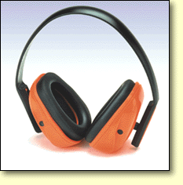

hearin hearhearing.

Is your
Hearing
out of Shape?
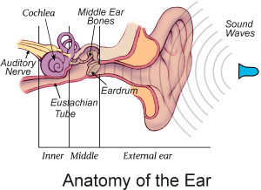
 
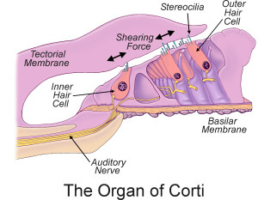
 

what happenS when I listen to loud music?
Hearing occurs when sound waves vibrate through your eardrum, middle ear bones, inner ear fluid, and stereocilia. Stereocilia are located in the Organ of Corti (which is housed within the snail-shaped Cochlea). In response to vibration, stereocilia stimulate nerve endings that send neural signals to the brain to be processed and interpreted. Stereocilia are like piano keys that give pure, precise and rich qualities to sounds.
Hearing loss occurs when the vibration of the stereocilia is too intense. These damaging sounds are like a tsunami wave that demolishes the cilia and other structures in its way. Having a hearing loss is like listening to a piano recital when only half the piano keys are played.

How can I tell if the music IS too loud?
Sound intensity is measured in decibels (dB). Unfortunately IPODs, walkmans and stereos don’t often display sound levels in decibels. Damaging sound levels start above 84dB and are dependent on the length of time you are exposed. As sound gets louder, safe exposure time gets shorter. Increasing sound by 4dB, decreases the safe exposure time by half!

Sound Level in dB | Safe Exposure Time
84 | 8hrs
88 | 4hrs
92 | 2hrs
96 | 1hr
100 | 30mins
104 | 15mins
108 | 7mins, 30secs
112 | ~3mins, 45secs
116 | ~1min, 45sec
120 | ~1min
124 | ~30secs
128 | ~15sec
132 | ~7.5secs
136 | ~3secs
140 | ~1sec

Typical noise levels | dB
Rustle of leaves | 15
Soft whisper | 30
Normal conversation | 55
Bird singing | 60
Vacuum cleaner | 70
Normal street traffic | 75
Alarm clock ringing | 80
Heavy city traffic | 92
Punch press | 100
Steel plate falling | 105
Hard rock music | 110
Jet passing overhead | 115
Jack hammer | 120
Jet plane taking off | 150

